**Educational Qualification**

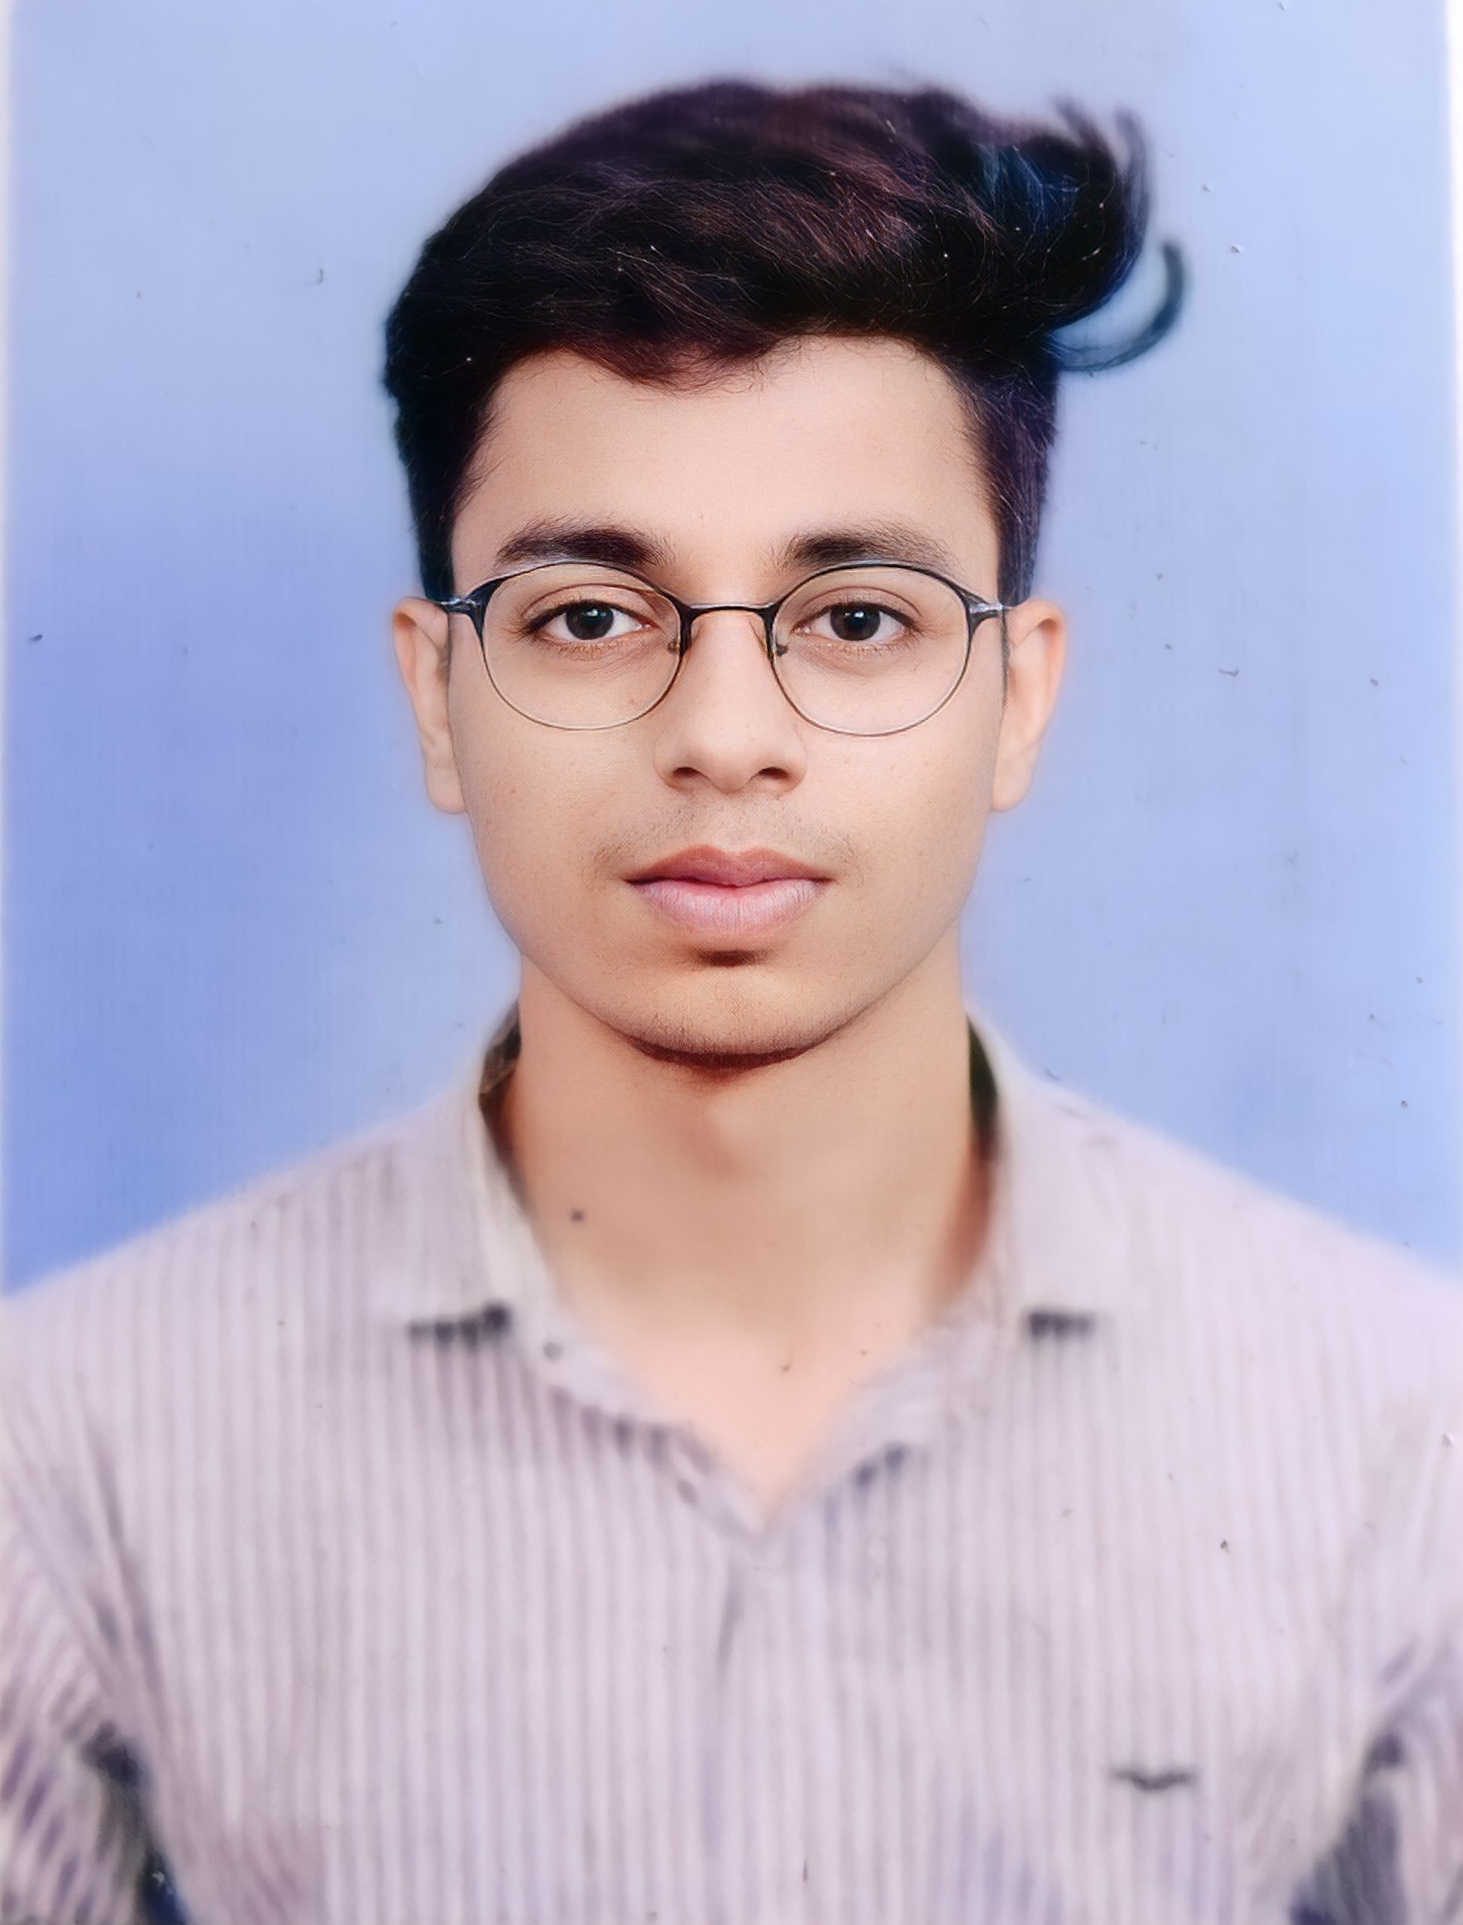

**Adarsh Patidar**

M.C.A- computer Applications

Gender: Male

Date of Birth: 26/09/2002

E-mail : 205123003@nitt.edu

Contact : +91-7489135477

|  |  |  |  |
| --- | --- | --- | --- |
| **Year** | **Degree/Examination** | **Institution/Board** | **CGPA/Percentage** |
| 2026 | MCA | NIT, Trichy | --- |
| 2022 | BCA | College of Professional Studies, Indore | 70% |
| 2019 | Class XII | Hind Junior college,  Shajapur ,M.P, CBSE | 60% |
| 2017 | Class X | Hind Junior College ,  Shajapur ,CBSE | 9.2 |

**Academic Achievements**

* Achieved first position in an Abacus competition during 11th grade.

**Internship Experience**

**Other Projects**

**Technical Skills and Certifications**

* Programming Languages : C, C++

**Positions of Responsibility**

* **Volunteer, Spielmac:** *Oct 2023 – Present*

Actively volunteered for the prestigious **Spielmac** event organized by **SOFTREC** at NIT Trichy, exclusively catering to MCA 1st-year students. Contributed to the event's success, engaging nearly every participant and supporting the seamless execution of activities

* **Coordinator, Sports :***Jan 2018*

I successfully organized and led a sports tournament within the school for three consecutive years as the Sports Captain. This initiative involved coordinating various aspects of the tournament, including logistical arrangements, team management, and event execution, showcasing consistent leadership and organizational skills.

**Extracurricular Activities**

***Social Activities:***

* A volunteer under the **U&I** **programme**, NIT Trichy chapter, which aims at providing individual attention and education and education to students with below average schooling.

***Sport Activities:***

* Represented and competed in gymnastics at the **State level** in 2017, showcasing dedication and skill in a competitive athletic setting.
* Achieved the title of **Mr. Spielmac** at the **Spielmac 2023** event in Nit Trichy, demonstrating outstanding performance and distinction among participants.